**P2 PROJECT**

**AI & Application Lab (14B17CI772)**

**1) Name : Kshitij Tandon Dept: CSE**

**E.no. : 201B139**

**2) Name : Pragya Sharma Date : 04/06/2022**

**E.no. : 201B183**

**Project Title : Sentiment Analyzer  
  
Description:**It is a analyzer tool whether the news stated in the article is positive , negative or neutral by using the natural language processing technique. It helps in finding the negative news which can harm the sentiments of the society or something related which can bring negativity in thoughts by reading those article.  
  
**Approach / Algorithm :**

* Import the nltk,nlp,newspaper ,text blob libraries
* Creating the GUI for the tool to work effectively.
* Defining the three sentiments – positive , negative , neutral.
* Making the program to accept the url and give the desired output.
* Return the author name , title , sentiment of the article provided**.**

**Code :**

import tkinter as tk

import nltk

from textblob import TextBlob

from newspaper import Article

def summarize():

    url = utext.get('1.0', "end").strip()

    article=Article(url)

    article.download()

    article.parse()

    article.nlp()

    title.config(state='normal')

    author.config(state='normal')

    publication.config(state='normal')

    summary.config(state='normal')

    sentiment.config(state='normal')

    title.delete('1.0','end')

    title.insert('1.0',article.title)

    author.delete('1.0','end')

    author.insert('1.0',article.authors)

    publication.delete('1.0','end')

    publication.insert('1.0',article.publish_date)

    summary.delete('1.0','end')

    summary.insert('1.0',article.summary)

    analysis = TextBlob(article.text)

    sentiment.delete('1.0','end')

    sentiment.insert('1.0',f'Polarity:{analysis.polarity} Sentiment:{"positive" if analysis.polarity > 0 else "negative" if analysis.polarity < 0 else "neutral"}')

    title.config(state='disabled')

    author.config(state='disabled')

    publication.config(state='disabledl')

    summary.config(state='disabled')

    sentiment.config(state='disabled')

root = tk.Tk()

root.title("News Summarizer")

root.geometry('1200x600')

tlabel = tk.Label(root, text="Title")

tlabel.pack()

title = tk.Text(root , height=1, width=140)

title.config(state='disabled',bg='#dddddd')

title.pack()

alabel = tk.Label(root, text="Author")

alabel.pack()

author = tk.Text(root , height=1, width=140)

author.config(state='disabled',bg='#dddddd')

author.pack()

plabel = tk.Label(root, text="Publication Date")

plabel.pack()

publication = tk.Text(root , height=1, width=140)

publication.config(state='disabled',bg='#dddddd')

publication.pack()

slabel = tk.Label(root, text="Summary")

slabel.pack()

summary = tk.Text(root , height=20, width=140)

summary.config(state='disabled',bg='#dddddd')

summary.pack()

selabel=tk.Label(root,text="Sentiment Analysis")

slabel.pack()

sentiment = tk.Text(root , height=1, width=140)

sentiment.config(state='disabled',bg='#dddddd')

sentiment.pack()

ulabel=tk.Label(root,text="URL")

ulabel.pack()

utext = tk.Text(root , height=1, width=140)

utext.pack()

btn = tk.Button(root , text="Summarize",command=summarize)

btn.pack()

root.mainloop()

**Test Procedures:**

Run the above code a dialog box will appear paste the article url and click the submit button to get the desired result.

**Results:**

The commands works perfectly fine on the system hence the Analyzer analyzes the articles in the link.

For eg:

https://edition.cnn.com/europe/live-news/russia-ukraine-war-news-05-31-22/index.html

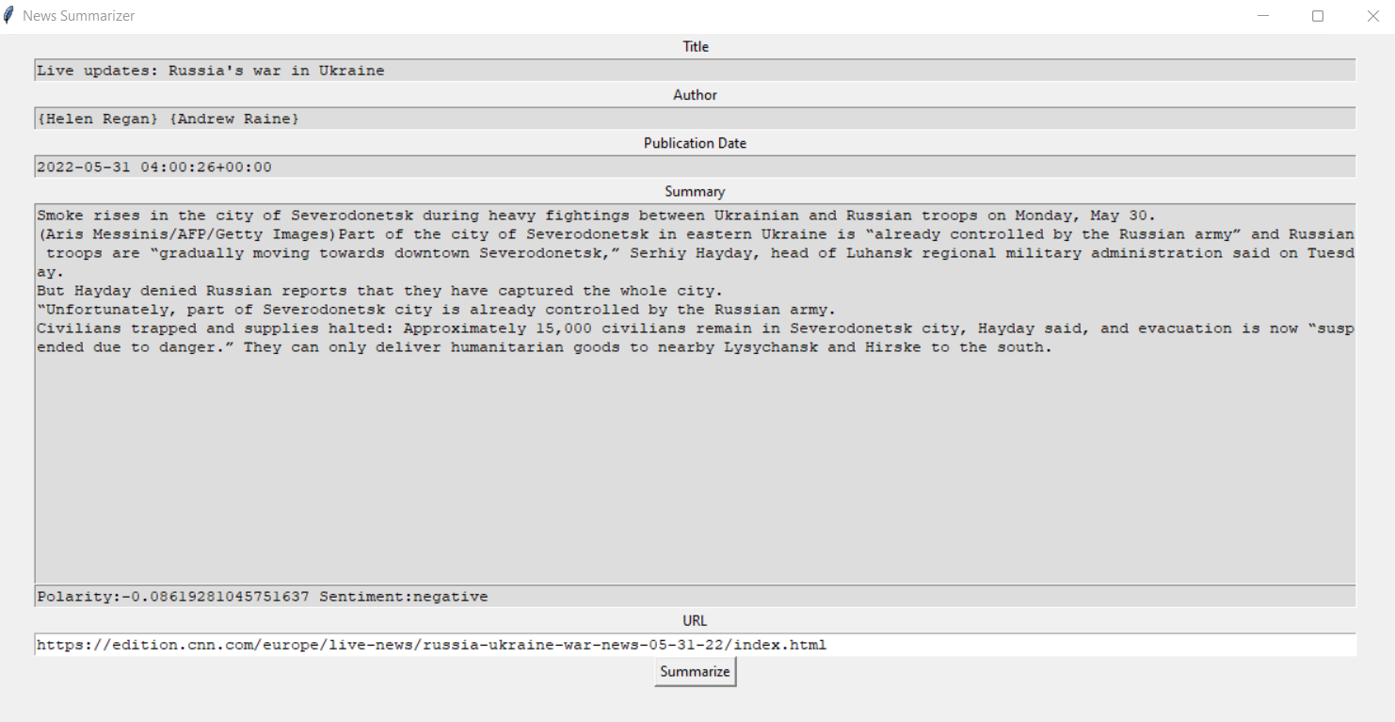

**Conclusion / Remarks:**

**Evaluation / Marks:**